DATUM | RAZRED | IME IN PRIIMEK
PLAN REZANJA | T | X | Y | Z
1  REZ3 G40, G41, G42  13  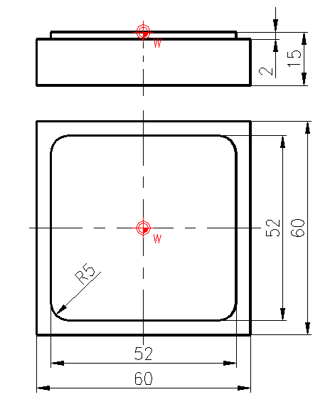  11  6  12  10  2  9  8  7  5  4  3 |  | -45 | 45 | 20
 |  | -35 | 35 | -2
 |  | -45 | 45 | 20

