DATUM | RAZRED | IME IN PRIIMEK

PLAN REZANJA |  | T | X | Y | Z
1,8,20  VAJA 2A  fi10  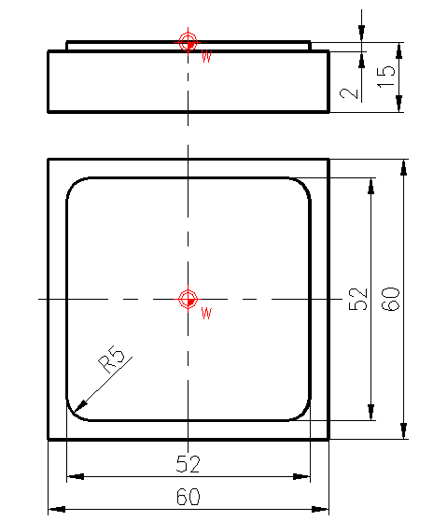  16  17  REZKAR fi40  18,19  6,  7  15  14  13  12  11  9,  10  4  5  2,3 | BREZ UPORABE KOREKCIJE ORODJA  G40, G41, G42 |  | -55 | 55 | 20
 | BREZ UPORABE KOREKCIJE ORODJA  G40, G41, G42 |  | -51 | 15 | 20
 | BREZ UPORABE KOREKCIJE ORODJA  G40, G41, G42 |  | -51 | 15 | 0
 | BREZ UPORABE KOREKCIJE ORODJA  G40, G41, G42 |  | 51 | 15 | 0
 | BREZ UPORABE KOREKCIJE ORODJA  G40, G41, G42 |  | 51 | -15 | 0
 | BREZ UPORABE KOREKCIJE ORODJA  G40, G41, G42 |  | -51 | -15 | 0
 | BREZ UPORABE KOREKCIJE ORODJA  G40, G41, G42 |  | -51 | -15 | 20
 | BREZ UPORABE KOREKCIJE ORODJA  G40, G41, G42 |  | -55 | 55 | 20
 | BREZ UPORABE KOREKCIJE ORODJA  G40, G41, G42 |  | -55 | 55 | 20

