T6,T7
DATUM | RAZRED | IME IN PRIIMEK
PLAN REZANJA | T | X | Y | Z
REZ1B  T1,T8, T22  W  Z  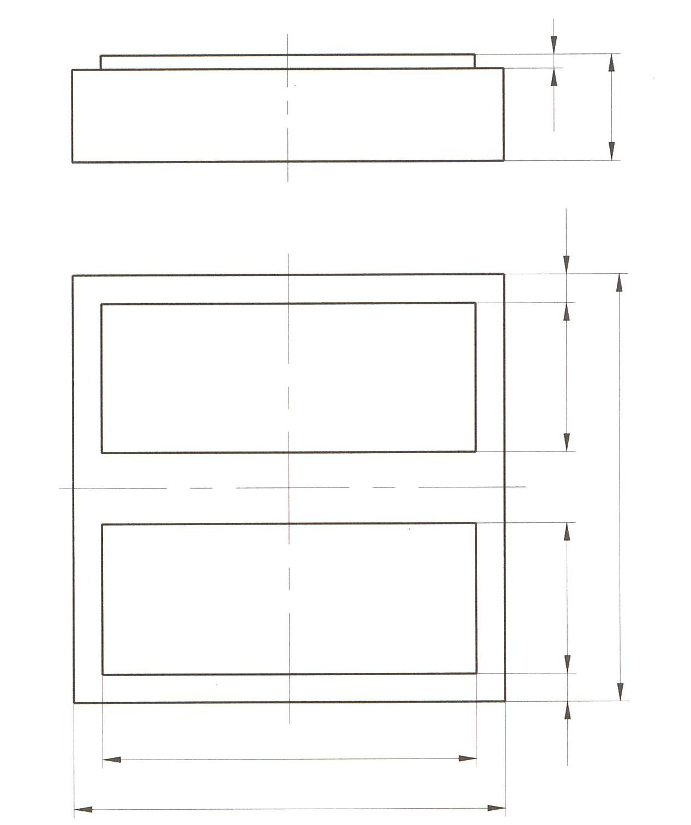  T20,T21  T9,T10  T19  T16,T170  T12  T14,T150  T11  X  T4  T2,T3  W  Y  T18  T5  T13 |  | -40 | 40 | 40
 |  | -51 | 15 | 40
 |  | -51 | 15 | 0
 |  | 51 | 15 | 0
 |  | 51 | -15 | 0
 |  | -51 | -15 | 0
 |  | -51 | -15 | 40
 |  | -40 | 40 | 40
 |  | -39 | 34 | 40
 |  | -39 | 34 | -2
 |  | 34 | 34 | -2
 |  | 34 | -34 | -2
 |  | -34 | -34 | -2
 |  | -34 | 34 | -2
 |  | -34 | 34 | 5
 |  | -39 | 3 | 5
 |  | -39 | 3 | -2
 |  | 30 | 3 | -2
 |  | 30 | -3 | -2
 |  | -30 | -3 | -2
 |  | -30 | -3 | 40
 |  | -40 | 40 | 40

